Catalogue
1、The Safety of Electronics and Mechanism 2
2、Security Alarm 3
3、Brief Introduction of microwave therapeutic instrument 5
4、Brief introduction of Microwave Medical Treatment 7
5、The Principle and Characteristics of Microwave Treatment 9
6、Major Component and Technical Parameters of Microwave Therapeutic Instrument 11
7、Installation and Debugging of Instrument 13
8、Instructions of Using and Operation 14
9、Maintenance、Cleaning and Disinfection 18
10、Common Faults and Elimination Methods 20

1、The Safety of Electronics and Mechanism
This equipment has been detected by sampling and proved to be consistent with the GB97O6.1-1995(part one of medical electronic equipment:general requirement) and GB9706.6—92(medical electronic equipment ,microwave therapeutic equipment, special safety requirement)standards

Equipment safety classification:it belongs to I group B type equipment

2、Security Alarm
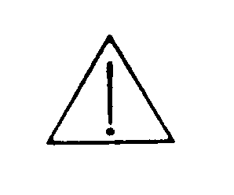
We are very grateful that you choose "Wiscon" brand products: microwave therapeutic instruments.Before your using,we hope that you can carefully read the instructions to obtain the best effect.
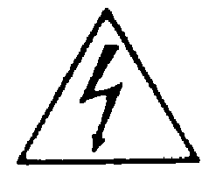Warning:high pressure,please don’t open the cover.The interior has no subassembly which user can maintain by himself and all the maintain work should be done by qualified personnel.
It belongs to I group B type equipment.Its protection to lightning stroke depends on basic insulation,which can control the electric current of electrical leakage within allowable value,what’s more,it has additional safe protection measures,which connect palpable conductor of equipment with protective earthing guideline in power-supply device so that palpable conductor will not charge even when basic insulation is out of service. Therefore, application environment must provide standard three-core electrical outlet with excellent ground.
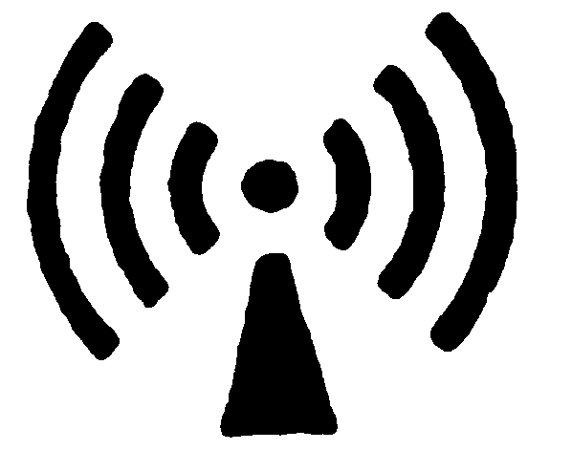warning:
1.microwave outlet must be connected with patchord and corresponding and should not turn on with empty load.
2.microwave output can be controlled only after microwave radiometer is placed in body part of patients,or there will be leakage.
3. the application of therapeutic and physiotherapeutic probe should be slelected according to actual demand.treatment of small part don’t need big probe.
4.these who don’t accept microwave treatment should keep at least one meter distance.doctors should wear safety glasses
5.radiator should not be put near metal objects or exposed in the air.when adjusting power you should wrap the radiator with damp
gauze,or put it in the 3:7 alcohol-watersolution.
6.microwave radiation shouid not directly aim at eye and testicle.
7.attention should be attached when pregnant woman accepts microwave treatment.it is strongly requested that their abdomen and private parts should not be irradiated.
8.patients who have cardiac pacemaker or metal objects in their bodies should not accept microwave treatment. Patients who have intelligence disability or low heat sensitivity usually don’t accept microwave treatment as their skin tissue are easy to be burned because of over high temperature during the treatment process.
All microwave joint must be correctly connected before usage to assure no microwave leakage.when the equipment works,please put the probe into patients ,then control microwave output.
Sign and pattern
Operators must be familiar with all warning signs and patterns in this handbook and marked on equipment.To use without identifying warning and reading related safe instructions will probably lead to injure.
Warning、caution and attention
Please pay sufficient attention to the following signs which appear in this handbook and on equipment:
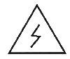
Warning：dangerous voltage


Warning：microwave radiation

Caution:”caution” reminds readers to pay attention to recommended matters and orders,disobey will lead to harm to equipment and human body.

Attention:“caution”provides additional information that should be given much attention。

3、Brief Introduction of microwave therapeutic instrument
MTC microwave therapeutic instrument is the product developed by Shanghai electronic and physical institute,who belongs to Shanghai university(original Shanghai science and technology university ) and is one of the units who applyed microwave technique into medicine in early time.It is also the technical achievement acquired by the institute’s cooperative research with Xinhua and Renji medical college who belong to The sceond medical university of Shanghai since 1984.Through the clinical application of many hospitals in and out of our city,it is deeply welcomed by medical workers.
- Product classification:
1.According to equipment classification it belongs to I group B type、mobile、normal equipment(seal equipment without anti-liquid-entering function )
2.Product pattern number:MTC-X X:design serial number(for example: 1,2,3…)
3.Structure:this equipment is composed of host and radiator
Host:MTC-3 is desk-top normal treatment equipment, MTC-3A is bogie-style treatment equipment.
Radiator :it is classified into operation、irradiance and endoscope radiator.
1) Operation radiator is used in treatment and its main patterns are:blunt- end、single-needle、double-needle、double-cross、three-cross radiator etc.they can be conveniently selected according to treatment area and usage.
2) Irradiance radiator is used in physiatrics and its main patterns are: cylindrical、circular aperture、antrum auris radiator. they can be selected according to treatment parts and area size.
3) Endoscope radiator is used in all kinds of endoscope: the diameter of flexible cable:φ2.4 andφ1.8mm,needle and blunt-end radiation head.
4. Accessories:foot switch、patchord、power line、terminal machine.
- Application range:
According to different departments,treatment equipments can be equipped with different radiators,in other words,there are various kinds of special microwave therapeutic instruments,such as endoscope、department of otolaryngology、department of gynecology、departmrnt of dermatology.Connecting with different radiators and with its output power and time being controlled, therapeutic instruments can generate thermal effect and non-thermal effect of different degree to do all physiatrics、thermotherapy and coagulation therapy and they are suitable for multiple clinical usage.
For example:
anal-intestinal department intestinal polyp、rectal cancer、internal nevus、perianal abscess、anal polyp etc.
gynecology vaginitis、pelvic inflammation、dysmenorrhea、episioitis、cervical polyp、cervical erosion、mastitis、latex obstacle
urological department prostatitis、prostatauxe、urinary tract infection
surgical department non-haemorrhage removalof polyemia tissue
department of dermatology all kinds of vascular cancer、all kinds of warts and nevus、skin cancerous protuberance、condyloma acuminatum、bromhidrosis、all kinds of skin ulceration、wound healing、all kinds of dermatitis and rash、oedema 、chilblain
surgical physiotherapy arthritis、periarthritis of shoulder、tendon inflammatory、sprain and contusion strain、infection etc.
otorhinolaryngology nasal hemostasis、polyp resection、epiglottic cyst、chronic tonsillitis、rhinitis、carcinoma of nasopharynx、vocal cord polyp、papilloma of external auditory canal、otitis media with effusion、sudden deafness
digestive department polyp of gastrointestinal tract、hematischesis、esophageal cancer、gastric cancer、stomach intestine dephlogisticate、ulcer solidification
- features: valid safe convenient reliable

4、Brief introduction of Microwave Medical Treatment
Microwave is ultrahigh frequency electromagnetic wave:
Its wavelength is between ultrahigh frequency radio wave and infrared lightwave,and the commenly used frequencies in medical treatment are 433 MHz、915 MHz、2450 MHz.
Microwave has certain penetrance to human body and can cause thermal and non-thermal effects.Using different radiators to control microwave power and time different curative effect can be achieved.
Microwave medical treatment mainly has three different application:
1.Physiotherapy
Using irradiance radiator to do local irradiation of big areas it causes certain osmosis.Local human body absorbs the microwave power and generate gentle haet effect which achieves the purpose of tendon relaxtion and activeation of blood circulation、dephlogisticate.There is no strict temperature rising which is generally 2-3℃.Its feature is that there is no need to take off cloth when doing extraorgan treatment.It can also does inserting physiotherapy,such as anus、vagina etc.
2.Tumor thermotherapy
Domestic and foreign clinic proves that when local tumor accepts 42-43℃thermotherapy assisted with radiotherapy or chemotherapy, curative effect can be greatly improved because of unusual (non-thermal) effect. Thermotherapy usually adopts outer lighting or inserting style radiator and needs to control temperature.Nowadays it develops rapidly and has good effect.Recently,through 915MHz thermotherapy and Co-60 radiotherapy, effective ratio(most tumor disappears ) upgrades from 50%(just radiotherapy) to 80% and it could lower the radiotherapy power as well.
3.tissue coagulation therapy
The general use of touching or inserting radiator lets microwave to generate high temperature(≥100℃) at very small parts of human body, which makes bleeding part cogulate and dry, polypi vaporize, obstruction dredge and tumor be necrosis etc.So it is widely used in digestive medical department、dermatology、department of gynecology、tumor operation etc.
It is proved by clinic to be safer and more convenient than laser therapy, For example,when using endoscope microwave therapeutic instrument to cure gastrorrhagia and gastric polyp,the effective rate approachs 98%.
Other application of microwave treatment:
1.medical linear accelerator 2.TCM microwave acupuncture
3.microwave imaging(tumor diagnosis)
4 disinfection、sterilization、thawing
The thermal effect of microwav
Thermal effect is generated by the strenuous exercise and mutual friction of charged particles and polarized moleculars under the effect of microwave field and can lead to the instant solidification of tissue.It has characteristics of no carbonization、no smoke、no abnormal taste、small damage、strong hemostatic function etc.
Meanwhile thermal effect can generate antiinflammatory and detumescence effects by means of dilating vessels of local tissue、accelerating blood circulation and tissue metabolism、strengthening leukocyte phagocytic phagocytosis、promoting absorption of local pathological metabolites. Hyperthermic effect can lead to pain relief by rescinding muscle spasm and scavenging accumulated lactic acid.
The non-thermal effect of microwave
Non-thermal effect means that when treating with microwave its heat quantity is so small that man can hardly feel it.Then it can generate physiological and therapeutic effects.In fact, local tissues can lead to temperature rising phenomena which can just be detected by precise temperature measuring instrument. Non-thermal effect has reliable curative effect in dephlogisticate and detumescence aspects.The progressiveness of microwave technology will make up the deficiency of electric cauterization、freezing、laser technology and the microwave technology has a fusion with multidisciplinary technology and will enlarge its application range all the time.

5、The Principle and Characteristics of Microwave Treatment
Using touching or inserting radiator microwave can generate high temperature at very small parts of human body and cause local coagulation of biological tissue to achieve operation or therapy purpose.
- Basic theory
Human tissue is a comparatively ideal load of microwave absorption(when water content>90%).Once microwave radiate,ultrahigh- frequency current around radiator generates heat to electric resistance of human biological tissue and causes temperature rising.The degree and range of temperature rising are determined by the characteristics of radiator、the frequcncy、power and action time of microwave.From microstand point,microwave can lead to ultra-high speed polarized vibration of biomolecule,which generates calory.
- Main characteristics
- Internal heating,high performance,quick
Because the heat source is not the radiator but human body tissue around it ,so it is called internal heating.what’s more,because of the bad heat conductivity of human body tissue(similar to cork wood),it is hard for calory to arrive exterior.so it has the features of high frequency and speed.It takes just few seconds to stop bleeding and coagulate.
- Easy control,strong applicability
The design of various kinds of radiators can meet therapy and operation request for different parts.For example, on one hand,you can insert small pinhead radiator at the end of slender coaxial cable into stomach to stop bleeding through endoscope biopsy hole,on the other hand,you can also use esophageal dilator radiator to dredge and congeal esophageal obstruction and it is widely used.
- Safe and reliable,no side effect
There is no need to adopt protection measures because the microwave leakage of this equipment is small and it is intermittency short emission. On the contrary,due to the disinfection and sterilization action of microwave,there is no need to consider infection and complication. Clinic proved that the microwave coagulation treatment may cause certain oedema,which will disappear automatically within several days.

6、Major Component and Technical Parameters of Microwave Therapeutic Instrument
Microwave therapeutic instrument is mainly composed of magnetron、filament supply、high voltage power、power control、time control、power、time display etc.
Magnetron is the source of microwave,and its power is controlled by additional anode high pressure.Power controller control magnetron anode high pressure and change output power.Time controller control working time of magnetron.
radiator
filament supply

high voltage power
magnetron
Power direction
power controller
time controller

Main technical parameters
Microwave frequency: 2450MHz±50MHz
Output power: treatment:0-100w adjustable
physiotherapy：0-40w adjustable
Time display: treatment:0-99s inverse timing
physiotherapy：0-99min inverse timing
Matched load impedance: 50Ω
Radiator stationary wave coefficient:<3.0
Main microwave leakage: ﹤0.05mW／cm²
Useless radiation of radiator: ﹤0.1mW／cm²
Duty: treatment and physiotherapy
Run mode: interspace load continuous running(load:20min, interspace: 10min)
Main voltage: 220V 50Hz AC
Power: 400VA
Volume and weight: MTC-3 type 433×388×166（mm）≥11kg
MTC-3A type 420×520×960（mm）≥18kg
Environmental condition:
1)transportation and storage:
a. Environmental temperature range:-10℃+55℃
b.relative humidity range: ≤85％
c.atmospheric pressure: 500hpa～l060hpa
2)operation:
a. Environmental temperature range:+10℃～+40℃
b.relative humidity range: 30％～75％
c.atmospheric pressure: 860hpa～l060hpa

7、Installation and Debugging of Instrument
1. A Must-read for installation and debugging
It belongs to I group B type equipment.Its protection to lightning stroke depends on basic insulation,which can control the electric current of electrical leakage within allowable value,what’s more,it has additional safe protection measures,which connect palpable conductor of equipment with protective earthing guideline in power-supply device so that palpable conductor will not charge even when basic insulation is out of service. Therefore, application environment must provide standard three-core electrical outlet with excellent ground. This equipment should not be used with two-core electrical outlet.
2.The equipment should be placed in ventilated and dry environment.
3.Preparations before start-up:
1)connect power line,output cable and radiator
2)insert the plug of foot switch(there is no need if just do physiotherapy)
3)press the key to adjust power and time.
4.Host aging
If the new machine or host has not been used for more than two months,they need electrifying and aging.Using the following method:
1)make good preparations before turning on the machine;
2)connect the operation radiator,and put it into a glass container full of water,and radiator head should be overwhelmed by water.
3)output style selection:first press the key for physiotherapy
4)time adjustation:press time key to adjust “+” towards 30minutes
5)power adjustation:press power key to adjust “+” towards 5-10W
6)press “start/stop” key,select output task,and the equipment can be normally used from now on.

8、Instructions of Using and Operation
(一)Appearance of therapeutic equipment(panel introduction)
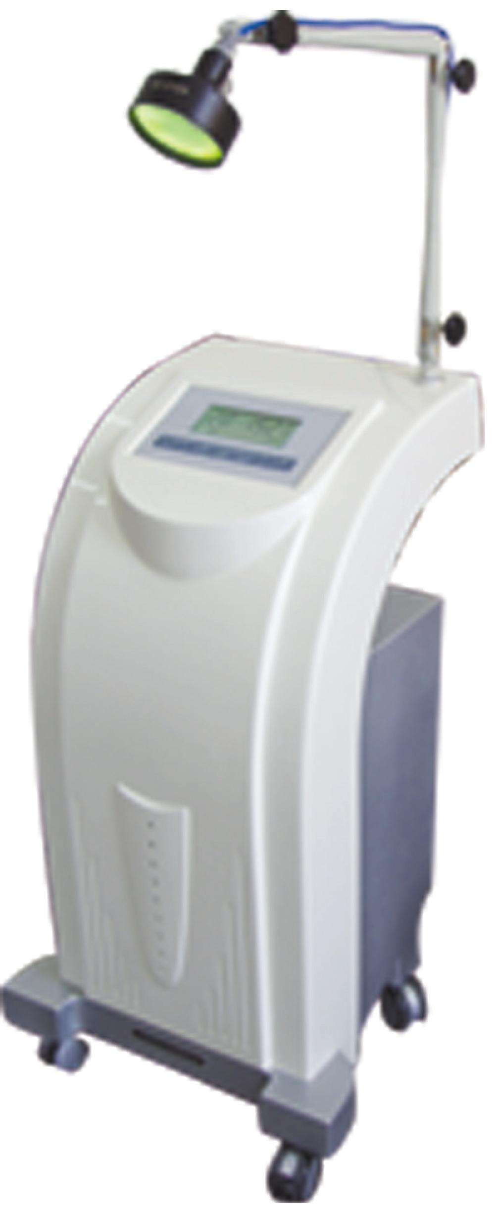
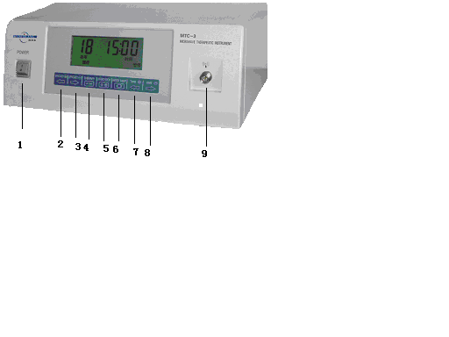
Figure 1
1.power switch 2.power increase 3.power decrease
4.treatment key 5.start/stop 6.physiotherapy key
7.time increase 8.time decrease 9.microwave output
Remarks:MTC-3A is bogie style,its power switch is on the left of the machine,and its microwave output is at the back,control desk is the same as MTC-3.
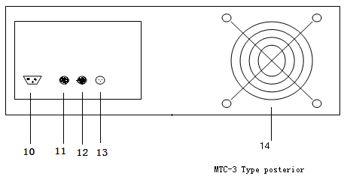
Figure 2
10electrical outlet 11fuse bench F3A fuse 12fuse bench F3A fuse
13foot switch outlet 14draft fan
(二)operation process
1.start-up preparations
1)connect the foot switch,and connect the needed related radiator and treatment or physiotherapy line with microwave output closely.
2)well connect the 220V power source and grounding line
3)turn on the power switch,display lights,ventilator revolve.At this time,working mode on the display is treatment,time displays incipient value 00:00,power displays incipient value 00:00.
4)After pre-heating for two minutes,select treatment or physiotherapy mode,adjust time and power to prepare for treatment.
2.Coagulation treatment
1)As for working status,please select “treatment” key,and in the middle of the display appears chinese words“treatment”
2) As for working time, please select “time +-” key,adjust the time to needed value,which generally is 3-5s.
3) As for output intensity, please select “power +-” key, adjust microwave power to needed value,which generally is 30-50W.
4)put the radiator into or closed to focus parts, step on foot switch, microwave power output and treatment starts.when focus become white and coagulate,unclamp foot switch, microwave power break,stop timing. Display decrease progressively by second,time for one time step should not be longer than five seconds.But it supports continuoue step for several times,and if step exceeds set time,system will stop wicrowave output and send out continuoue alarming sound when time is over(display is 00). Unclamp the foot switch time will turn back to previous setting. Continuous step will lead to continuous working output.
3.Irradiance physiotherapy
1)select and connect microwave physiotherapy radiator,screw union joint, aim at and paste closely to focus parts
2) As for working status,please select “physiotherapy” key,and on the display appears chinese words“physiotherapy”
3) As for working time, please select “time +-” key,adjust the time to needed value,which generally is 10-20min.
4) As for output intensity, please select “power +-” key, adjust microwave power to needed value,which generally is 5-20W.
5)press“start/pause”key and microwave output starts,press it again and the output will pause.
6)while physiotherapy,the ideal power is the one that can keep warm but not too hot.Power output should be adjusted according to different patients.The physiotherapy time decreases progressively by count-down. when timing turns to zero,buzzer of therapeutic equipment will send out warning sound continuously and time displays 00:00 which means physiotherapy is completed.Time returns to previous setting.Repeat the above operation and another patient will accept physiotherapy.
4 Transformation of treatment and physiotherapy output mode
1)when turning on the machine its acquiescent output mode is treatment, and the treatment time is calculated by second. Therapeytic line can be connected with any kind of therapeytic head,adjust time and power,switch controls the output.
2)If there is need for you to transfer therapeutic to physiotherapeutic mode please press “physiotherapy” key.Under physiotherapeutic status time is calculated bu minute. Physiotherapeutic line can be connected with any kind of physiotherapeutic head,adjust time and power,press “start/pause” key to control the output
5.precautions for use
1) because that different people have different impedance and thermal sensitivity,when doing physiotherapy,there may exist possibilities for one patient to feel too hot ,under this condition power should be decreased properly.
2)microwave power should be cut off when replacing radiator.it is forbidden to put through microwave equipment with no load.
3)After using for several times if the thermal effect of therapeutic probe becomes worse,you should clean the head of radiator first and should not just increase microwave power without consideration
4)please assure the good connection between radiator and cable. If apinoid radiator has poor thermal effect and the cable connector is very hot please examine the connector to make sure whether there is smudge when lighting. If there is smudge please clean them with alcohol.Then if the cable connector is still very hot please change cable.
6.used microwave power reference
category | coagultion treatment | Inseting style irradiance | φ80 radiator irradiance | φ30 radiator irradiance | otology irradiance
power（W） | 20～50 | 10～20 | 10～30 | 5～10 | 5～10

The microwave power of irradance should be adjusted on the basis of assuring affected part warm but not too hot.and the microwave power of coagulated treatment should be adjusted on the basis of assuring affected part white but not fired.

9、Maintenance、Cleaning and Disinfection
1.maintenance of whole machine
The whole machine need to be opened and cleaned once a year,the dusk in it can be cleared by dust collector.
Microwave power output connector should accept periodic inspection(at least once a month) If there are serious smudges of large area and can not be erased,the machine should not be used again and be sent to our company for change,orherwise it will demage the magnetron.After cleaning,you can use it when alcohol fully volatilizes.
2.cable connection
(1)microwave connector should accept regular examination,it should be cleaned with absolute alcohol once a month.If you discover smudge please erase it in time. And if there are serious smudges of large area and can not be erased,the machine should not be used again and need change,orherwise it will demage the magnetron.After cleaning,you can use it when alcohol fully volatilizes.
(2)when using the cable should not be twisted,otherwise it will damage cable and affect using.
3.radiator
(1)the maintenance of microwave connector on radiator is the same as the two strips mentioned above.
(2)the head radiate parts of radiator such as single needle、double needle、double cross should be cleaned with alcohol at once after their using,but they should not shaved bu sharp tools which will affect using.
(3)attention:when cleaning the head of radiator,expecially the head of endoscope radiator,you should clean from head to back.if on the contrary,it is easy to damage radiate head.
4.cleaning and disinfection of radiator
Microwave has self disinfection function to radiator,so the cleaning and disinfection of radiator is the same as general operation instruments. and it is cleaned with medical alcohol without other special request.
- Using other company’s accessories will affect the performance and effect of this equipment.if there is some accident we will not take the responsibility.

10、Common Faults and Elimination Methods
phenomenon | possible reasons | elimination methods
Display and fan don’t work | 1.power line has bad connection  2.the internal part of equipment is too hot.  3.fuse is burnt out | 1.assure good connection of .power line  2.cooling  3.change the fuse F3.0A
Both treatment and physiotherapy has no output | 1.output port and output line is loose  2.output  3.bad connection between probe and output line  4.the treatment status is not set  5.no foot switch  6.power and time is not set  7.foot switch has not connection or is damaged | 1.tighten the connecting line  2. replace output line  3.examine and connect it  4.set treatment status  5.step on footswitch  6.set time and power  7.replace footswitch
physiotherapy has output but treatment has no output | 1.treatment line is damaged  2.treatment probe is ageing or damaged. | 1.replace treatment line  2.replace treatment probe
treatment has output but physiotherapy has no output | 1 interface generate heat  2.physiotherapy line breaks  3.physiotherapy line has poor contact | 1.tighten interface  2.replace physiotherapy line  3.examine or replace probe
Foot switch loses efficacy | 1.foot switch socket is loose  2.foot switch line is exfoliated  3.foot switch is damaged | 1.examine and tighten the connecting line  2.examine and connect it  3.replace footswitch
The effect of treatment and physiotherapt is not ideal | 1.output line and output end are loose | 1.check and tighten them
Probe breakdown | 1.there is power but no output  2.probe line breaks | 1.replace the probe  2.replace the line
Cable line generates heat and is too hot | 1.power is too large  2.radiator breaks and can not send out microwave which is consumed in cable.  3.microwave connector has poor connection | 1.decrease power  2.replace radiator  3.connect again or replace connecting line
The replacement of fuse and other parts
1.you must trun off the power source and pull out power plug before replace fuse,the rated value of fuse must be the same as original one and cmust not be increased arbitrarily.
2.other parts with special request should not be replaced arbitrarily and has no adjustable hole which user can adjust by himself.

